Movie Picture pipeline evidences.

Working url for frontend-

http://aba02385700cd4825a4f835828a35d04-885867026.us-east-1.elb.amazonaws.com

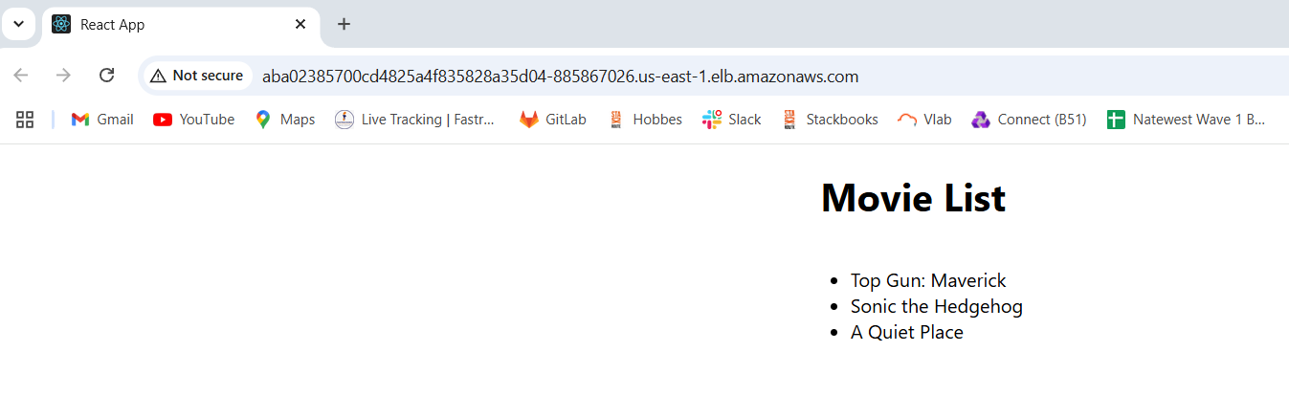

Working url for backend

http://a0a3917b151ab4834bf3fe1e56e5b56c-2115556434.us-east-1.elb.amazonaws.com/movies

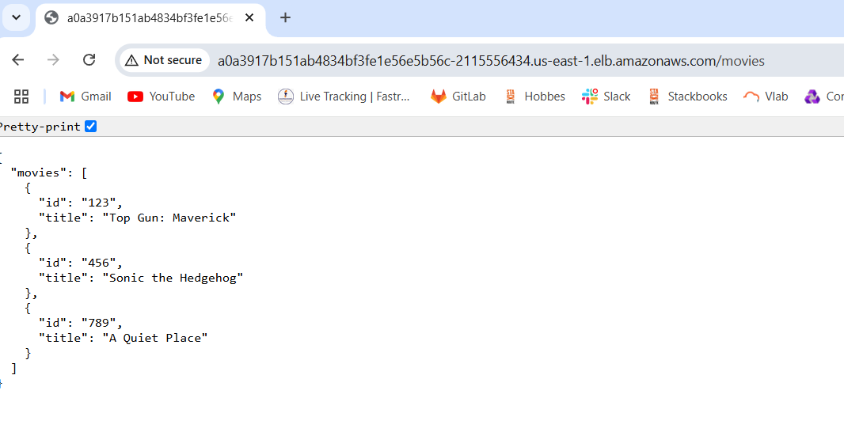

**Backend Continuous Integration**

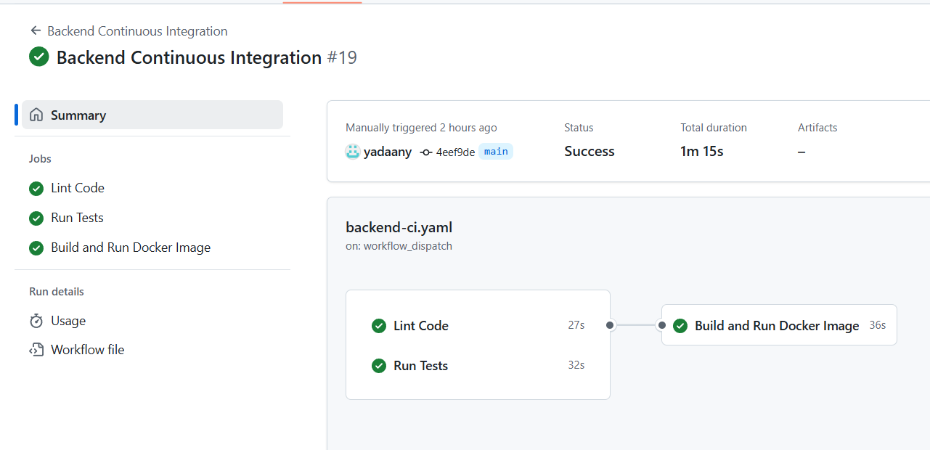

**Backend Continuous Deployment**

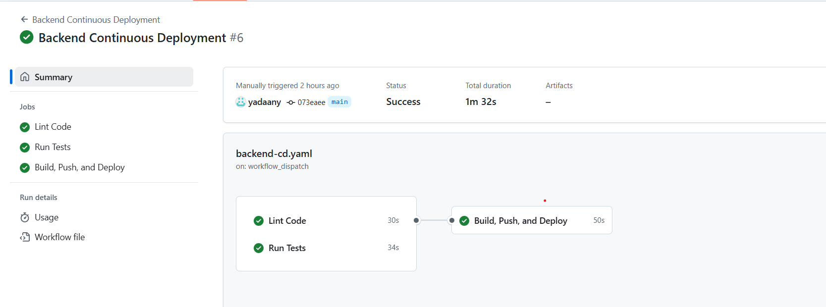

**Frontend Continuous Integration**

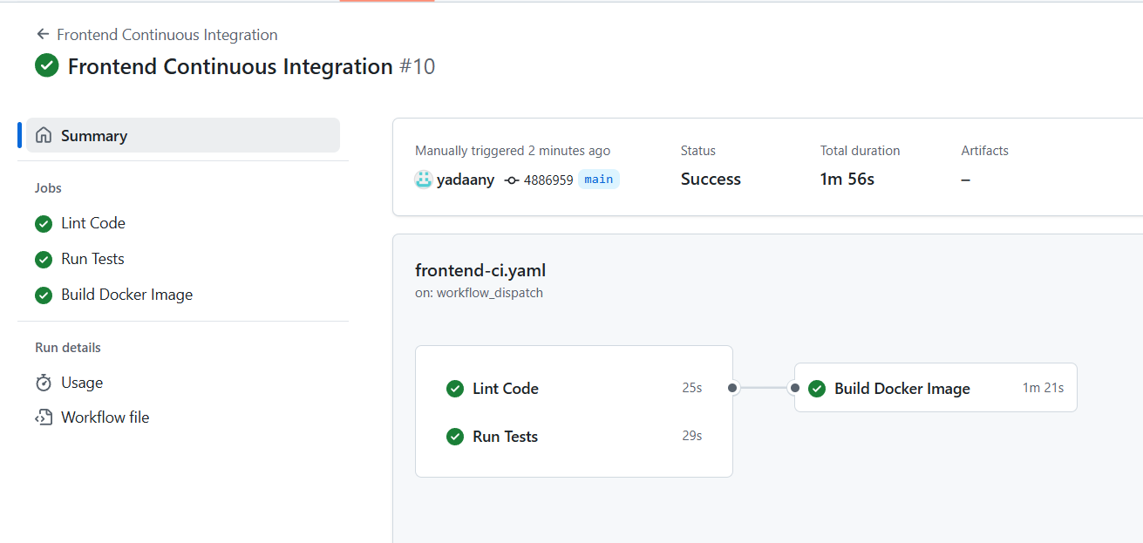

**Frontend Continuous Deployment**.

